Split-belt adaptation – try a higher effort group?
Effort condition selection during experiment design: Initial effort group conditions were selected based on data from a study by Puthoff et al. (2006) that showed O2 consumption was significantly elevated during level ground walking in weighted vest conditions with 10, 15, and 20% BW (Puthoff et al. 2006). We selected the 15%BW condition with the aim of inducing changes in metabolic cost without inducing changes in gait kinematics and without causing fatigue and discomfort. Work by Gaffney et al. (2022) suggests that gait kinematics are largely resilient to added weight and Bastien et al. (2005) reports that loads up to 25% BW are sustainable for efforts lasting up to 6 hours (Bastien et al. 2005; Gaffney et al. 2022).
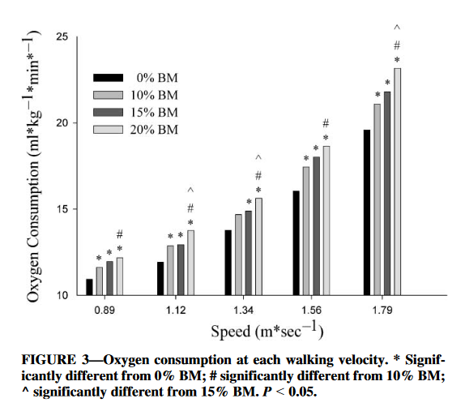
(Puthoff et al. 2006)
Question: should we try a higher effort group?
Why: Simply, is more effort needed to trigger changes in adaptation? Does the effort cost need to surpass some threshold in order to modulate learning?
Incline walking has been shown to accelerate locomotor adaptation and to improve the extent of adaptation (Sombric et al. 2019). This could be related to the balance of ground reaction forces, but also may be related to the effort cost of incline walking.
Positing that, if effort related, the effort demands at the 8.5 degree incline are sufficient to impact motor learning, we need to compare the effort demand of weighted walking to that of incline walking. Applying findings from Butterfield and Collins (2019), I assume that the metabolic cost of split-belt walking is similar to the cost of tied walking at the average of the belt speeds (Butterfield 2022). I further assume that this principle applies to incline split-belt as well. Since both my weighted split-belt study and the incline split-belt study used a 3:1 belt speed ratio with 1.5 / 0.5 m/s belt speeds, we can examine data on the cost of walking at 1m/s to gauge metabolic cost of walking in the two tasks.
Ludlow and Weyland (2016) compared loaded walking and incline walking, measuring metabolic costs at three different speeds, including 1m/s, and four different inclines, including level (no incline) and 9-degrees (Ludlow and Weyand 2016).
Using their data, I can compare measures of metabolic cost for incline walking (9-degrees, unweighted) to that of weighted walking (no incline, + some percent BW).
They found that added weight, up to the maximum measured (30%BW), increased metabolic rate (W/kgBW) proportional to the amount of weight added. This means that rates based on total weight (BW + additional) were near constant and sensitive only to speed and incline.
*(This finding is consistent and true in weighted walking with higher loads too. A study by Bastien et al. (2005) had people walked at various speeds (including 1.1m/s) with added weight up to 75% BW, showed that increases in metabolic rate were proportional to added weight.(Bastien et al. 2005)
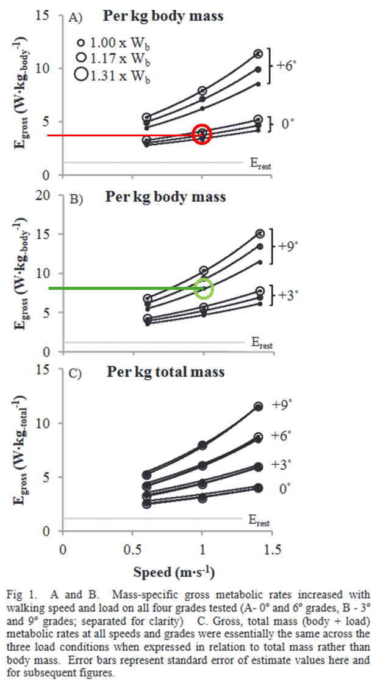
(Ludlow and Weyand 2016)
With respect to incline, they found that incline increased metabolic rate, with greater increase occurring at higher walking speeds.
They report the data for gross metabolic rate in a figure duplicated to the right. I assumed that walking with 17% added weight was similar to walking with 15% added weight (corresponding data point circled in red) and assumed that walking on a 9 degree incline was similar to walking on an 8.5 degree incline (corresponding data point is circled in green). Basically, the gross rate of weighted walking (15% BW) is half of the gross rate of walking on a 9-degree incline.
Furthermore, up to 30% BW, the increase in gross rate associated with weighted walking on level ground is still only about 70% (visual estimate) of the cost of inclined walking.
Ludlow and Weyland (2016) also fit an equation to describe the relationship between all three factors:
$E_{walk}=\left(0.528*incline+2.2677\right)*speed$
Where $E_{walk}= E_{gross}- E_{resting (supine)}$, $E_{walk}$ is in W/kg(BW + added), incline is in degrees, and speed is in m/s.
Using this equation, weighted walking as previously measured (with 15% BW added), has a rate cost $E_{walk}\left[\frac{W}{1.15kgBW}\right]=2.2677$ and $E_{gross}\left[\frac{W}{kgBW}\right]=2.608 \left[\frac{W}{kgBW}\right]+ E_{rest}=3.77 [\frac{W}{kgBW}]$when $E_{rest}=1.16 [\frac{W}{kgBW}]$ as reported in the paper.
For the inclined walking, the equation predicts $E_{walk}\left[\frac{W}{1.15kgBW}\right]=\left(0.528*8.5\deg{+ }2.2677\right)=6.76 \left[\frac{W}{kgBW}\right]$, so that $E_{gross}\left[\frac{W}{kgBW}\right]=7.92 [\frac{W}{kgBW}]$ when the resting rate is added.
These predictions are consistent with the data in the figure above, but at best, apply only to the range of conditions in the study (walking with incline (0,3,6,9 degrees), added weight (at torso, 0,15, 30% BW), and three speeds (0.6, 1.0, 1.4 m/s)). Back calculating, their equation suggests that to match 8.5 degree incline walking, a person would have to carry nearly 3x their bodyweight; this is clearly too far to extrapolate, but gives an idea of how big the gap between weighted and incline walking costs seems to be.
Conclusion: while we cannot rule out an effort magnitude threshold for effects on split-belt adaptation (effort must surpass some level to cause changes), it also seems infeasible to “effort match” prior work on incline walking. If desired, we could add an additional effort group at 25%BW while remaining in a sustainable effort range.
Additional, but not fully explored, Looney et al. have validated a prediction model called Load Carriage Decision Aid (LCDA) using metabolic cost measurements from many studies of weighed (Looney et al. 2018) and inclined (Looney et al. 2019) walking – I could use this model to calculate incline / weight effort equivalents.

Bastien GJ, Willems PA, Schepens B, Heglund NC. Effect of load and speed on the energetic cost of human walking. Eur J Appl Physiol 94: 76–83, 2005.
Butterfield JK. The Energetics of Split-Belt Walking [Online]. Stanford University2022.https://www.proquest.com/docview/2787197223/abstract/C8ACE15D10554029PQ/1 [6 May 2024].
Gaffney CJ, Cunnington J, Rattley K, Wrench E, Dyche C, Bampouras TM. Weighted vests in CrossFit increase physiological stress during walking and running without changes in spatiotemporal gait parameters. Ergonomics 65: 147–158, 2022.
Looney D, Potter A, Pryor JL, Bremner P, Chalmers C, McClung H, Welles A, Santee W. Metabolic Costs of Standing and Walking in Healthy Military-Age Adults: A Meta-regression. Medicine and science in sports and exercise , 2018. doi:10.1249/MSS.0000000000001779.
Looney DP, Santee WR, Hansen EO, Bonventre PJ, Chalmers CR, Potter AW. Estimating Energy Expenditure during Level, Uphill, and Downhill Walking. Medicine & Science in Sports & Exercise 51: 1954–1960, 2019.
Ludlow LW, Weyand PG. Estimating loaded, inclined walking energetics: No functional difference between added and body mass. In: 2016 IEEE 13th International Conference on Wearable and Implantable Body Sensor Networks (BSN). 2016 IEEE 13th International Conference on Wearable and Implantable Body Sensor Networks (BSN), p. 306–311.
Puthoff ML, Darter BJ, Nielsen DH, Yack HJ. The Effect of Weighted Vest Walking on Metabolic Responses and Ground Reaction Forces. Medicine & Science in Sports & Exercise 38: 746, 2006.
Sombric CJ, Calvert JS, Torres-Oviedo G. Large Propulsion Demands Increase Locomotor Adaptation at the Expense of Step Length Symmetry [Online]. Frontiers in Physiology 10, 2019https://www.frontiersin.org/articles/10.3389/fphys.2019.00060 [25 Jul. 2023].

